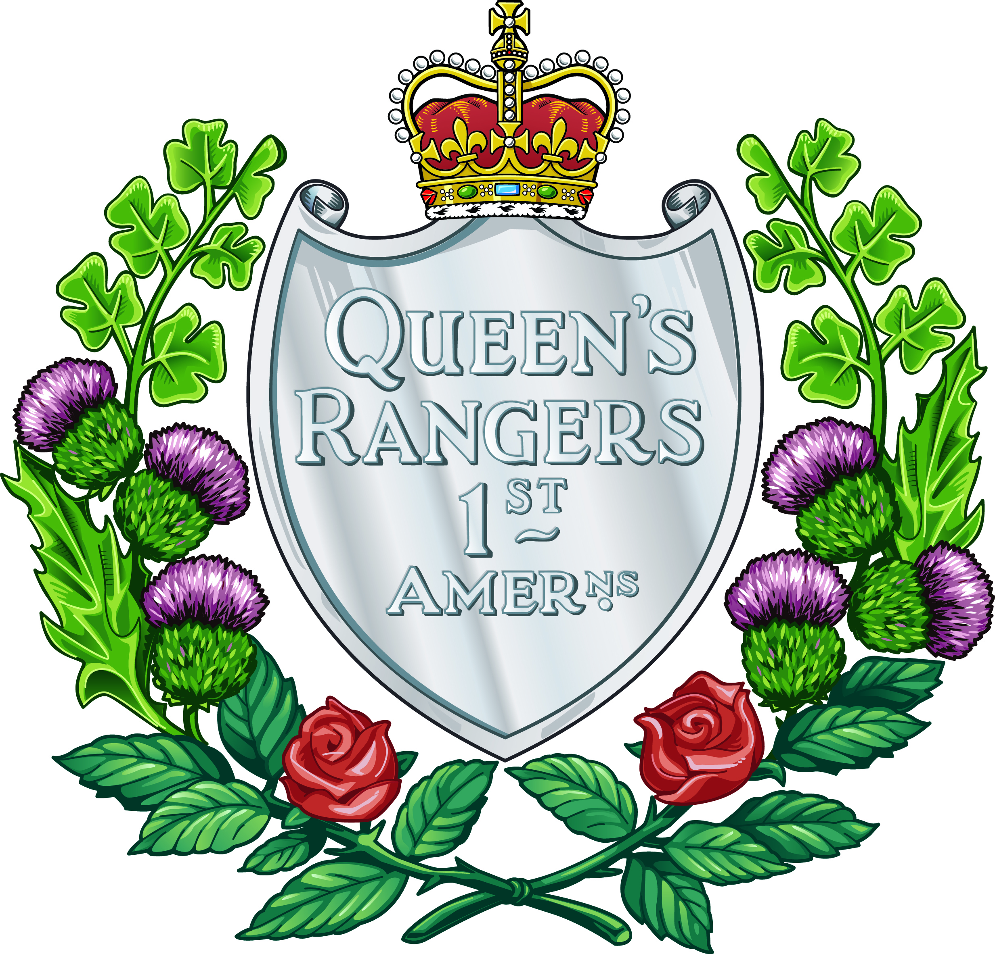
Exploring History and Identity:
The Guidon of
The Queen's York Rangers
(1st American Regiment)(RCAC)
Grade 7 Social Studies Lesson Plan (Ontario)
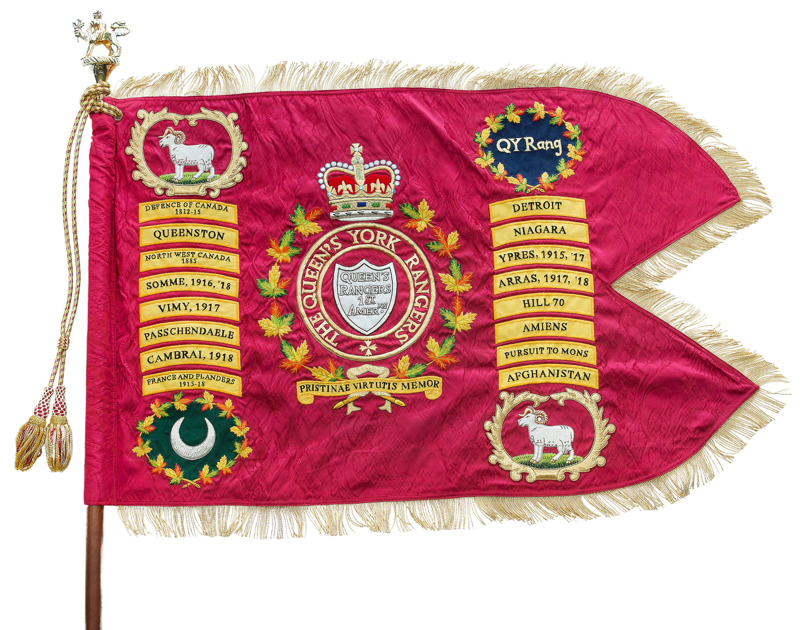

Ontario Curriculum Connections: Grade 7 Social Studies (History – 2026/2027 expectations)

A1. Application: Colonial and Present-day Canada

analyse aspects of the experiences of various groups and communities, including First Nations, Métis, and Inuit communities, in Canada between 1713 and 1800, and compare them to the lives of people in present-day Canada (FOCUS ON: Continuity and Change; Historical Perspective)

A2. Inquiry: From New France to British North America

use the historical inquiry process to investigate perspectives of different groups and communities, including First Nations, Métis, and/or Inuit communities, on some significant events, developments, and/or issues related to the shift in power in colonial Canada from France to Britain (FOCUS ON: Historical Significance; Historical Perspective)
B1. Application: Changes and Challenges

analyse aspects of the lives of various groups and communities, including First Nations, Métis, and Inuit communities, in Canada between 1800 and 1850, and compare them to the lives of people in Canada in 1713–1800 (FOCUS ON: Continuity and Change; Historical Perspective)

B2. Inquiry: Perspectives in British North America

use the historical inquiry process to investigate perspectives of different groups and communities, including First Nations, Métis, and/or Inuit communities, on some significant events, developments, and/or issues that affected Canada and/or people in Canada between 1800 and 1850 (FOCUS ON: Historical Significance; Historical Perspective)

B3. Understanding Historical Context: Events and Their Consequences
describe various significant people, events, and developments, including treaties between Indigenous nations and imperial powers, in Canada between 1800 and 1850, and explain their impact (FOCUS ON: Historical Significance; Cause and Consequence)

Learning Goals
By examining the symbols on the regimental guidon, students will explore events such as the War of 1812 and its participants as a way of discovering the developing identities of Canada and Ontario (formerly Upper Canada).

Success Criteria
Students can identify regimental symbols, explain battle and theatre honours, and describe, through an exploration of The Queen’s York Rangers, important moments in Canada’s military history and their connections to Ontario’s and Canada’s identities.

Background for Teachers
A regimental guidon is a sacred, swallow-tailed ceremonial flag carried by armored and cavalry units to represent their history, honour, and battle achievements. Read more here: Our Guidon — The Queen's York Rangers Regimental Council
For Grade 7 Social Sciences, teachers should emphasize the regiment’s American colonial history prior to and through the American Revolution, as well as honours Defence of Canada 1812-1815, Detroit, Queenston, and Niagara.

Materials/Resources
Guidon image, map of Upper Canada, chart paper, digital tools (The Queen's York Rangers' Virtual Museum, Swift and Bold, The Queen's York Rangers), Swift and Bold: The Queens York Rangers (Celebrating the Armoury’s Sesquicentennial), Swift and Bold: the story of The Queen’s York Rangers (1st American Regiment) (RCAC)
Learn more about the Sesquicentennial of the John Graves Simcoe Armoury:
ONTARIO – Canadian Military History
Ontario Heritage Trust | Aurora Armoury
Aurora Armoury Historical Plaque

Minds On (15 Minutes)
Teacher shares an image of the regimental guidon of The Queen’s York Rangers with students. Using an assortment of suggested materials and resources, students analyze the guidon and brainstorm what its symbols and names reveal about the regiment’s history and identity, as well as the histories and identities of Ontario and Canada.
Things to focus on: The name “Queen’s York Rangers (First American Regiment),” the Crown, the battle and theatre honours, the maple leaves, crest, and the crescent moon.

Activity (40 Minutes)
This can be done as a class, or in groups.
Part 1: Investigate the symbolism of the crescent moon, white rams, crown, and battle honours. Also pose the question, “What’s in a name?”, and invite students to unpack the name The Queen’s York Rangers (1st American Regiment), discovering its links to the early settlement of Upper Canada by American refugees, including the work of the “Queen’s Rangers,” as well as the settling of York County by the “York Rangers”. The story of Lieutenant Governor John Graves Simcoe would be particularly valuable to highlight.
This investigation could be conducted using students’ devices, as well as relevant sections of Swift and Bold: The Queen’s York Rangers (Celebrating the Armoury’s Sesquicentennial) and Swift and Bold: The Story of The Queen’s York Rangers (1st American Regiment) (RCAC).
Part 2: Focus on the battle honours Detroit, Queenston, and Niagara, as well as the theatre honour Defence of Canada, 1812-1815, and explore what these battles and campaigns meant for the formation of Ontario and Canada as we know them today.

Consolidation (20 Minutes)
Students create a mind map, poster, or other form of media that explains the regiment’s symbols and links The Queen’s York Rangers to important moments in Canada’s military history. The connections between the regiment’s identity and Ontario’s and Canada’s identities should be highlighted.

Additional Step
Students could send their creations to the Regimental Council of The Queen's York Rangers at:
The Queen's York Rangers Regimental Council
P.O Box 38641, RPO Cummer
North York, Ontario M2K 2Y5

